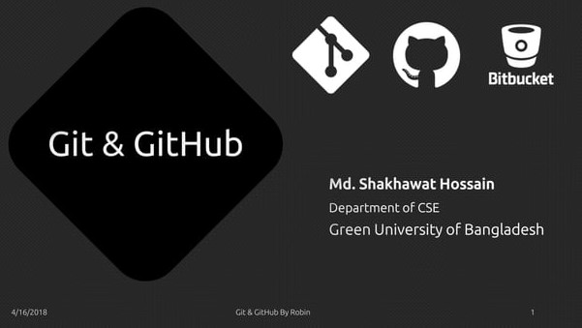

# Overview

What is Version Control?

What is Git?

How does Git work?

What is GitHub?

Install Git

GitHubBy

What is Version Control?

What is Version Control?

* A system that keeps records of your changes
* Allows for collaborative development
* Allows you to know who made what changes and when
* Allows you to revert any changes and go back to a previous state

Gitg By

What is Cit?

What is Git?

* Global Information Tracker
* Git is a distributed version control system
* Every dev has a working copy of the code and full change history on their local machine _BY Linus Torvalds.
* Started in 2005
* Created by Linus Torvald to aid in Linux kernel development

# git

How does Git work??

How Does Git Works?

. Commit

. Repositories

* Cloning
* Pulling
* Pushing
* Branches
* Merging

## Commit

* Can be a noun or verb
* "l commited code"
* "'I just made a new commit"
* Essentially, a project is made up of a bunch of commits
* Commits contain three pieces of information:
* Information about the changed from previous
* A reference to the parent commit
* A hash code name: f2d2ec5069fc6776c80b3ad6b7
* The short form of repo is knows as repository in Git
* It's a collection of all the files and the history of those files
* Basically it's a place where all your hard work is stored

## Cloning

* The act of copying a repository from a remote server is called cloning
* Cloning from a remote server allows teams to work together

## Pulling

• The process of downloading commits that don't exist on your machine from a remote repository is called pulling changes

### Pushing

• The process of adding your local changes to the remote repository is called pushing changes

### Branches

* All commits in git live on some branch
* But there can be many, many branches
* The main branch in a project is called the master branch
* A bunch of commits linked together that live on some branch, contained in a repository

Gitg By

### Merging

• Once you're done with your feature, you merge it back into master

CitHubBy Rotsn

What is GitHub?

4/'6/2-018 GitgCitHubBy Røbn

### GitHub

GitHub is a web-based hosting service for version control using git www.github.com

Largest web-based git repository hosting service

• Aka, hosts 'remote repositories'

Allows for code collaboration with anyone online

Founded in 2008

Free for students as part of the Student Developer Pack.

Gitg By

BitBucket

www.bitbucket.org

Largest web-based git repository hosting service

Allows for code collaboration with anyone online

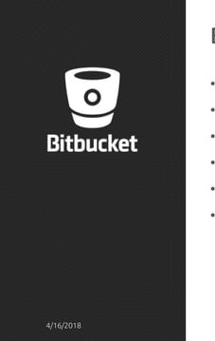Adds extra functionality on top of git

Founded in 2010

Free for up to 5 users

Gita CitHubBy

Install Git?

Git8CitHub

## Install Git

Linux (Debian) — Command: sudo apt-get install git

Linux (Fedora) —

Command: sudoyum install git Mac—

http://git•scm.com/download/mac Windows

http://git-scm.com/download/win

Gitg By Rotsn

Thank You All

Git